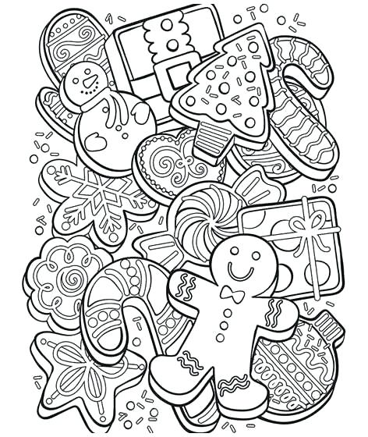

Student’s Name_____________________________________________

Parent’s Name______________________________________________

Grade:_4th_____5th_____Phone_____________________________________________

E-mail address_____________________________________________________________________

Please color the picture on the opposite side of this form and return to:
The Genoa Chamber of Commerce Office 113 N. Genoa St. by November 27th.
If office is closed please place in the folder in Chamber mailbox.

The first place winner from each grade will get to march in the parade the night of
“Celebrate the Season,” and win a prize.

Each winner will also be announced at the Community tree lighting that evening.

Join in the fun at Celebrate the Season on December 2nd from 6:00 to 8:00.
There will be Santa, a petting zoo, wagon rides, face painting, letters to Santa, food, hot chocolate, crafts and more!
Jingle Bell parade starts at 6:00 pm at the corner of Sycamore St. and Rt. 72.

Santa’s House will also be open from 10am-1pm
December 3rd, 10th, 17th & 24th
Santa House Location: Next to Heartland Bank, Main Street

Genoa Area Chamber of Commerce / 815.784.2212 / info@ genoaareachamber.com

